Aim: Practical demonstrate to validate PAN card number and Email ID.
IDE:
For this experiment, you only need the built-in re library for regular expressions, which comes with Python.
Validating a PAN Card Number
PAN Card Format:
- A PAN (Permanent Account Number) card in India consists of 10 characters.
- The first five characters are uppercase letters (A-Z).
- The next four characters are digits (0-9).
- The last character is an uppercase letter (A-Z).
Regular Expression:
^[A-Z]{5}[0-9]{4}[A-Z]{1}$
import re

def validate_pan(pan):
pattern = r'^[A-Z]{5}[0-9]{4}[A-Z]{1}$'
if re.match(pattern, pan):
return True
return False
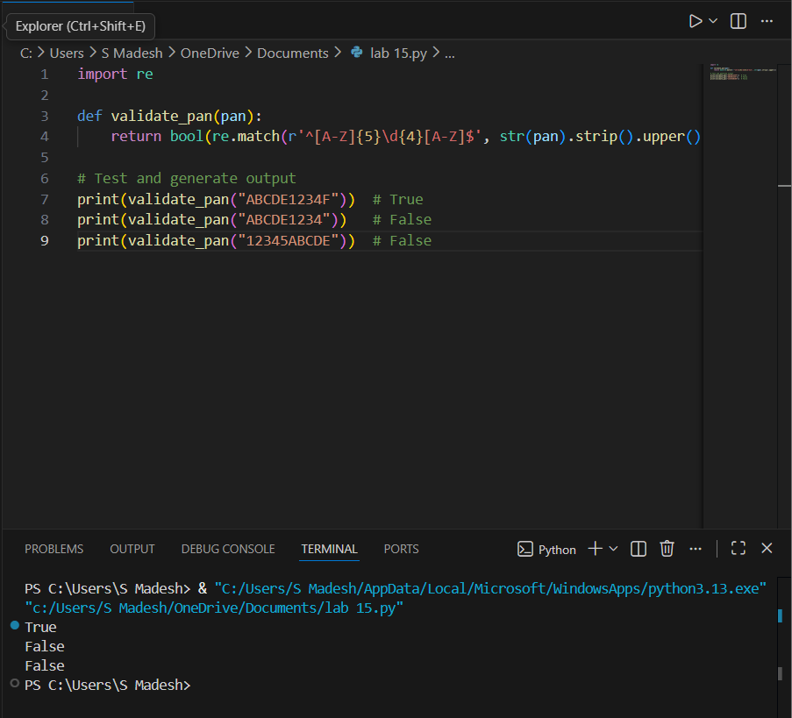

# Test the function
pan_number = input("Enter PAN card number: ")
if validate_pan(pan_number):
print("Valid PAN card number.")
else:
print("Invalid PAN card number.")
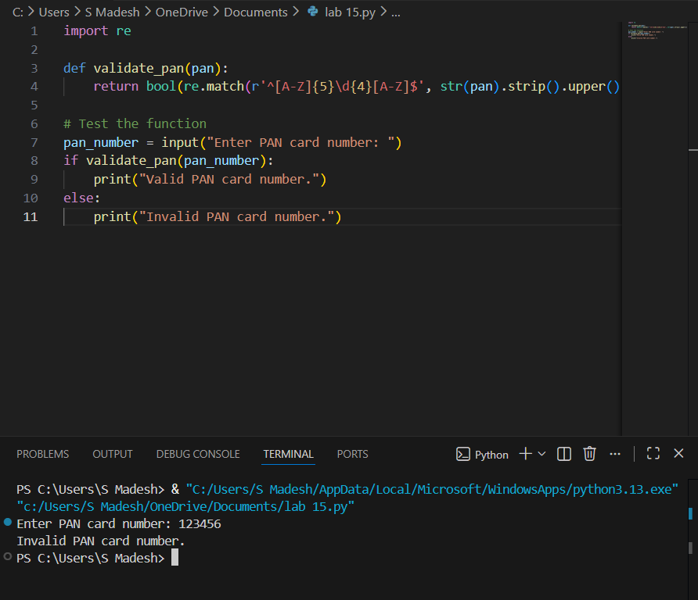
Validating an Email ID
Email Format:
- An email consists of local and domain parts, separated by an @ symbol.
- The local part can include letters, digits, dots, underscores, and hyphens.
- The domain part should consist of a domain name and a top-level domain (TLD), such as .com, .org, etc.
Regular Expression:
^[a-zA-Z0-9._%+-]+@[a-zA-Z0-9.-]+\.[a-zA-Z]{2,}$
def validate_email(email):
pattern = r'^[a-zA-Z0-9._%+-]+@[a-zA-Z0-9.-]+\.[a-zA-Z]{2,}$'
if re.match(pattern, email):
return True
return False
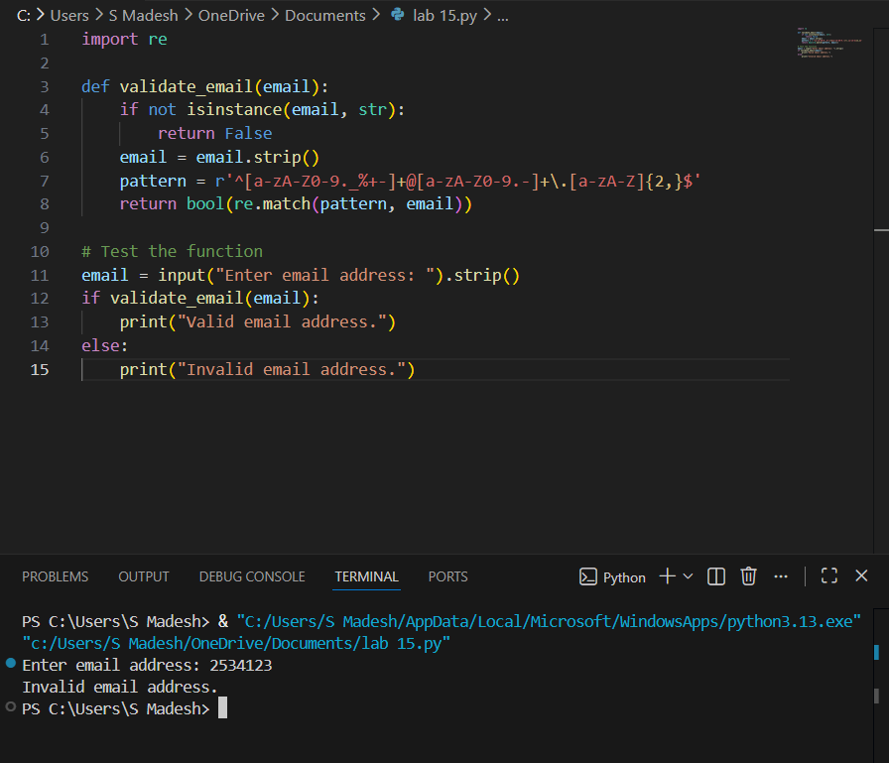

# Test the function
email_id = input("Enter email ID: ")
if validate_email(email_id):
print("Valid email ID.")
else:
print("Invalid email ID.")
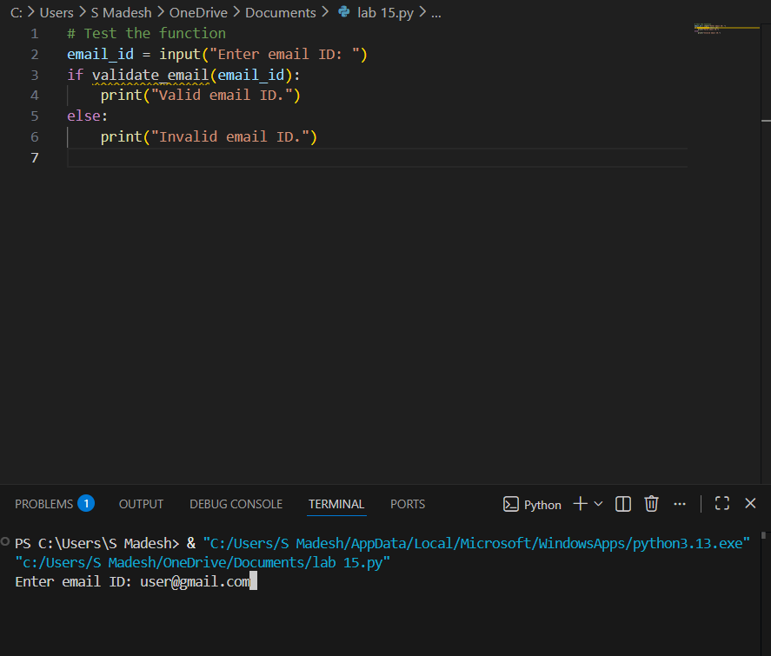

Post Lab:
Write a code combine both validations into a single program
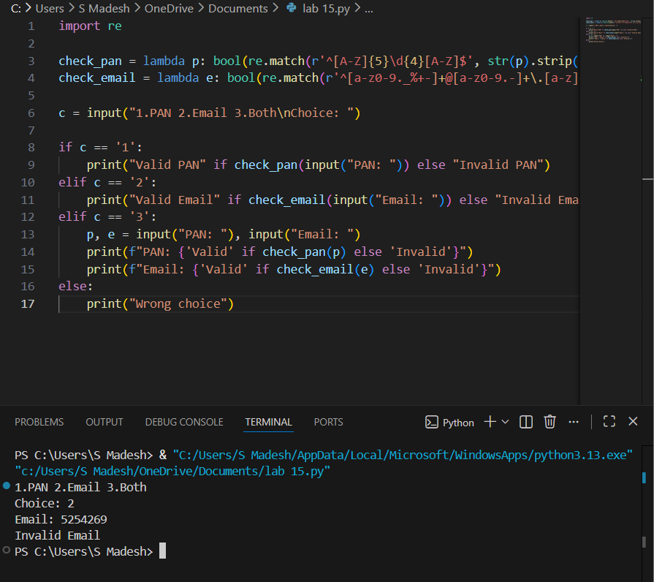

Github link: https://github.com/bandikatlapraveen142715/python-labs

